Big Mountain is a premium ski resort near Glacier National Park and Flathead National Forest. Currently the resort bases its lift ticket pricing on a market average plus a premium. Recently, an additional chair lift was added that increases Big Moutain’s operating costs by $1.54M. It is suspected that Big Mountain could charge more for its lift tickets based on its premium location and structure. The purpose of this project is to determine the features of ski resorts in the same market as Big Mountain that most strongly contribute to price. This information will be compared to Big Mountain to determine a proper pricing strategy. This information will also be used to suggest future improvements and determine if any of Big Mountain’s current operations could be removed as a cost reduction to further drive profit.

Data from 330 Ski Resorts, including Big Mountain, were examined. These data included lift ticket price and resort features such as State, number of lifts, vertical drop, number of runs, and skiable area. Data were cleaned and features and entries that did not add value to the results were discarded. Other values were calculated based on the state each resort was located in to determine if there were any regional effects. The data did not show any regional effects and the state information was eventually discarded. The final data set analysed consisted of 277 resorts.

Initial exploration of the data were conducted. The heatmap of all features indicated that there were some distinct correlations to analyse.

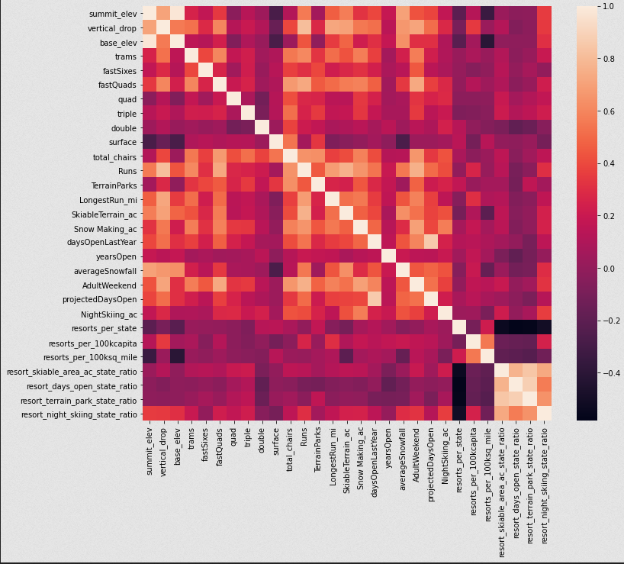

Fig. 1: Heat map of correlation between all features

These features were graphed against ticket price with distinct correlations observed between the price and Vertical drop, number of Fast Quad lifts,total number of chair lifts, and total number of runs. These features were hypothesized to relevant in the final modeling.

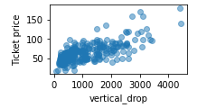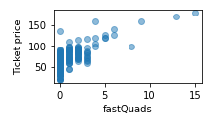

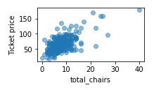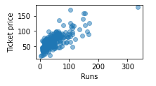

Fig. 2: Graphs of Relevant Features vs. Ticket Price

Non numeric values were removed from the dataset and a two models were trained with a 70/30 test/train split. These were a simple linear regression and a Random Forest Regression. Simply taking a mean of the pricing data led to a model with a Mean Absolute Error (MAE) of 19. This indicates that the mean of the pricing data, when used a pricing model, would vary from the actual value by about $19. Of the two models, the Random Forest was found to have a better fit than the linear regression with an MAE on the Test Data of 9.5 vs. an MAE of 11.8 from the linear regression. Both models showed that the number of fast quad lifts, number of runs, snow making ability, and vertical drop had the biggest effect on pricing.

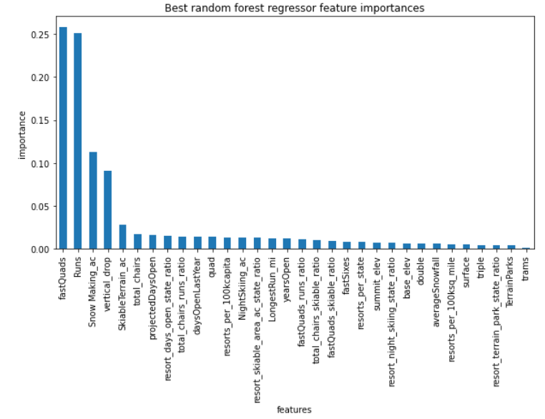

Fig. 3: Importance of features on price in the models

Currently the Big Mountain Adult Weekend Lift Ticket Price is $81. The average Lift Ticket price for the other resorts in the market is $63. Assuming that Big Mountain has 350,000 visitors a year and each visitor stays 5 days (buys 5 lift tickets), to increase revenue by the operating cost of the new chair lift ($1.54M), the ticket price would need to be increased by $0.88/Ticket. The model developed above shows that Big Mountain could raise the Ticket Price by $10.39/Ticket (to $95.87) and be in line with other resorts in the market assuming all costs are equal. This is reasonable as Big Mountain is at the higher end of the curve for most relevant features.

With respect to possible cost reductions, the model suggests that closing one run will not affect prices or revenue, closing 2 will affect it some, and closing 3-5 runs would have greater but equivalent effects. If the cost savings are greater than about $1.25M it could prove worth it to close 1 to 5 of the least popular runs. Adding another, bigger, run would support raising the ticket price by $1.99 for an additional $3,474,638 in revenue. Increasing the Snow Making area makes no difference to the ticket price when adding a run. Increasing the longest run on the mountain will have associated costs but will not support increasing ticket prices. These recommendations could be tested by briefly closing 1, 2, and 5 runs, reducing the ticket price accordingly and determining if the cost savings are more than the lost revenue.

There were a few missing attributes in this model. The costs associated with each of the features is unknown. If some features are much more costly, they could be more attractive targets for cost savings than the model would indicate. The number of visitors per year for the other resorts in the market would also prove useful as a benchmark for costs. A resort with a large volume could charge less than a premium heli-skiing experience.